PERSONAL FINANCE TRACKER – PROJECT DOCUMENTATION

- Project Title:
Personal Finance Tracker (Using Object-Oriented Programming in Python)
- Objective:
The goal of this project is to design and implement a Personal Finance Tracker that enables users to efficiently manage their income and expenses.
It helps users record, categorize, and analyze financial transactions with a focus on using OOP principles such as encapsulation, inheritance, and polymorphism.
- Tools and Technologies:
Component | Details
Programming Language | Python 3.x
Libraries Used | csv, os, datetime, matplotlib
IDE / Editor | Visual Studio Code / PyCharm
File Handling | CSV File Storage (transactions.csv)

4. System Requirements:
Hardware:
- Any modern PC or laptop
- Minimum 4GB RAM
Software:
- Python 3.x installed
- Matplotlib library (pip install matplotlib)
- Code Editor (VS Code / PyCharm)

5. Dataset (CSV File: transactions.csv)
ttribute | Description | Example
Date | Date of the transaction | 2025-11-06
Type | Income or Expense | Income
Category | Type of source/spending | Salary / Food / Rent
Description | Additional details | Monthly Salary
Amount | Amount of transaction | 20000

6. Project Description:
The Personal Finance Tracker is a simple yet effective console-based system that:
- Records Income and Expense transactions
- Displays all past transactions
- Calculates total income, total expenses, and net balance
- Generates monthly expense charts using Matplotlib
- It demonstrates Object-Oriented Design, File Handling, and Data Visualization.

7. OOP Concepts Implemented:
OOP Concept | Implementation in Project
Class & Object | Transaction, Income, Expense, Account, ReportGenerator classes
Encapsulation | Data attributes (amount, category, date, description) are accessed via methods
Inheritance | Income and Expense classes inherit from Transaction
Polymorphism | The get_type() method behaves differently for Income and Expense
Abstraction | ReportGenerator class hides implementation details of data visualization

8. System Design:

Class Diagram
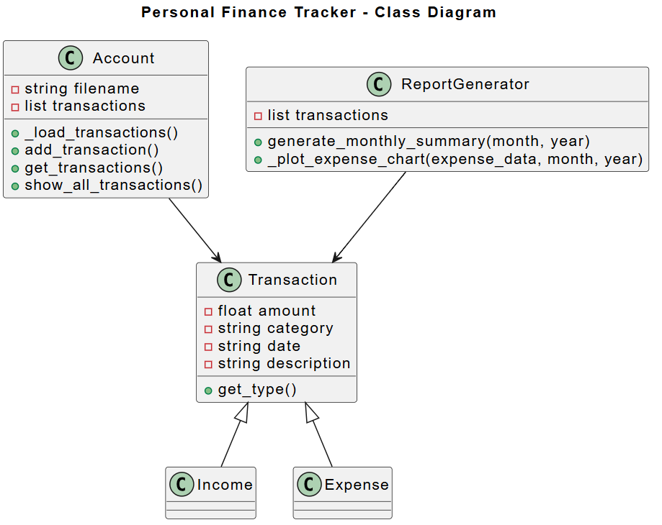

9. ER Diagram:
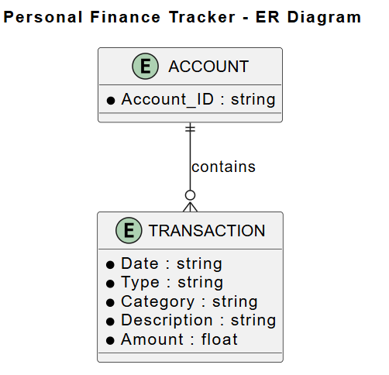

Explanation:
- One Account can have many transactions
- Each Transaction belongs to one Account
- Transaction can be either Income or Expense

Conclusion:
The Personal Finance Tracker provides an efficient, object-oriented way to manage personal finances.
It demonstrates the power of OOP principles (Encapsulation, Inheritance, Polymorphism, and Abstraction) in building modular and maintainable applications.

